Redcliff and Brickyard Lane September 2026
Sadly I had to miss this trip again due to family commitments but thanks to Tricia, Denise and David for photos. David Lepper’s Facebook page has many more of the trip.
I would love to have seen the mining bee aggregations in the cliffs, probably Ivy Mining Bees and possibly Sea Aster Mining Bees too. I can’t tell from the photos.
Ivy Mining Bees, Colletes Hederae, are making an appearance everywhere this autumn. First seen in this country in 2001 in Dorset they are quickly moving north (so far recorded up to County Durham, I saw them last week in Swaledale) ) and I have seen them even in my own garden this mild September. They take advantage of the lack of competition at this time of year and collect ivy pollen to feed their larvae, the adults emerging from their nesting tunnels much later than other common mining bees.
Do record them (on iNats?) if you see them. Here’s a recent quote that is so true:
“This country needs every entomologist it can muster, as insects are first responders to climatic change. We need a parish entomologist network” Matthew Oates, The Times, September 20th 2026

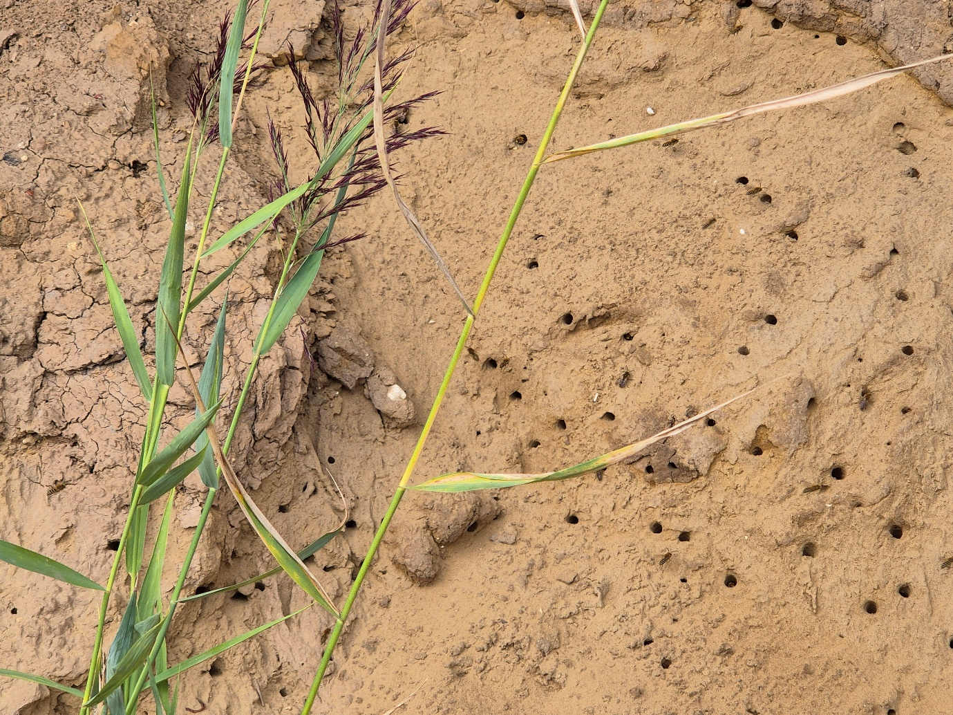
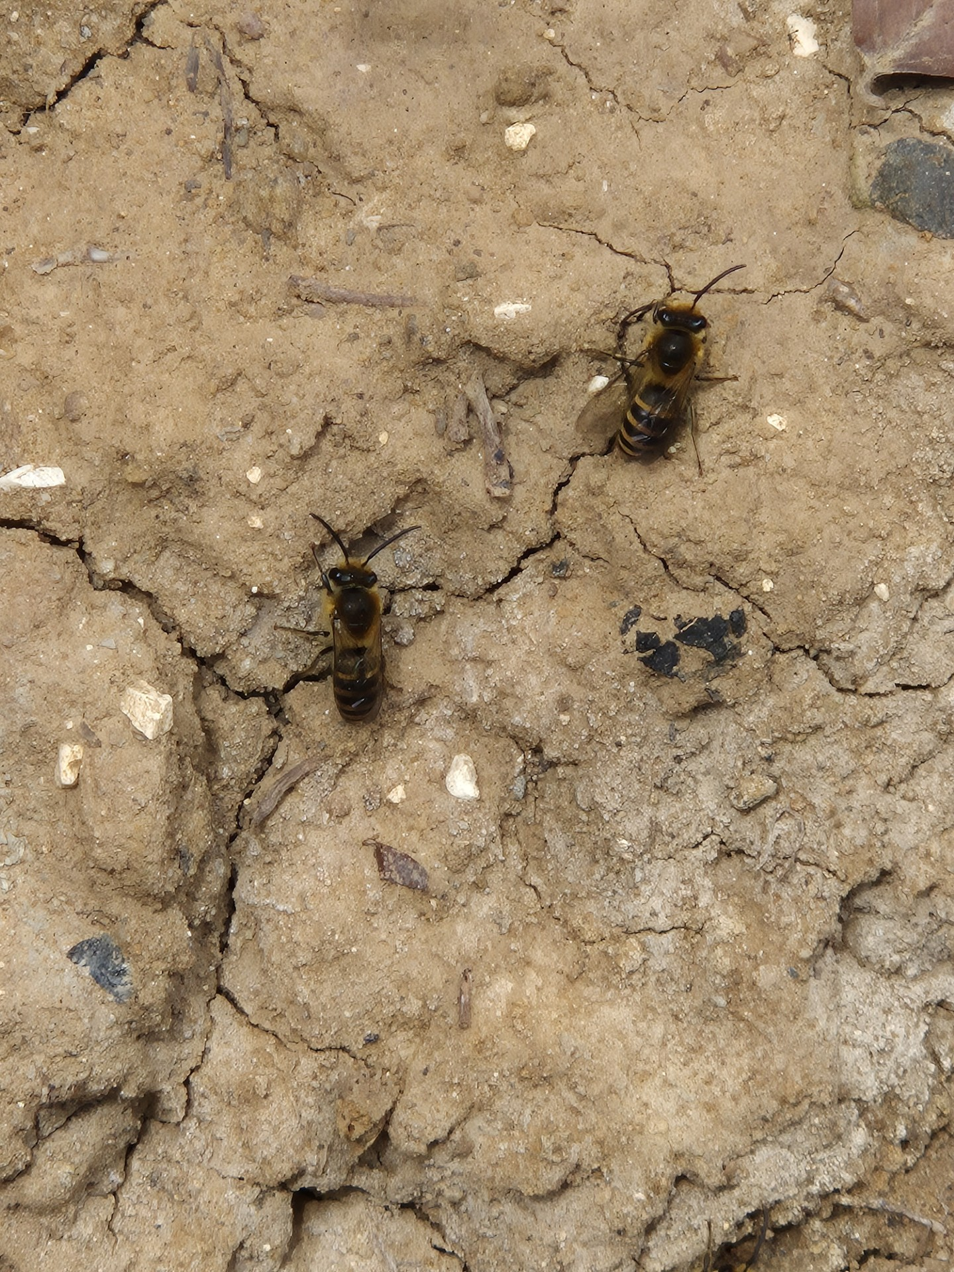

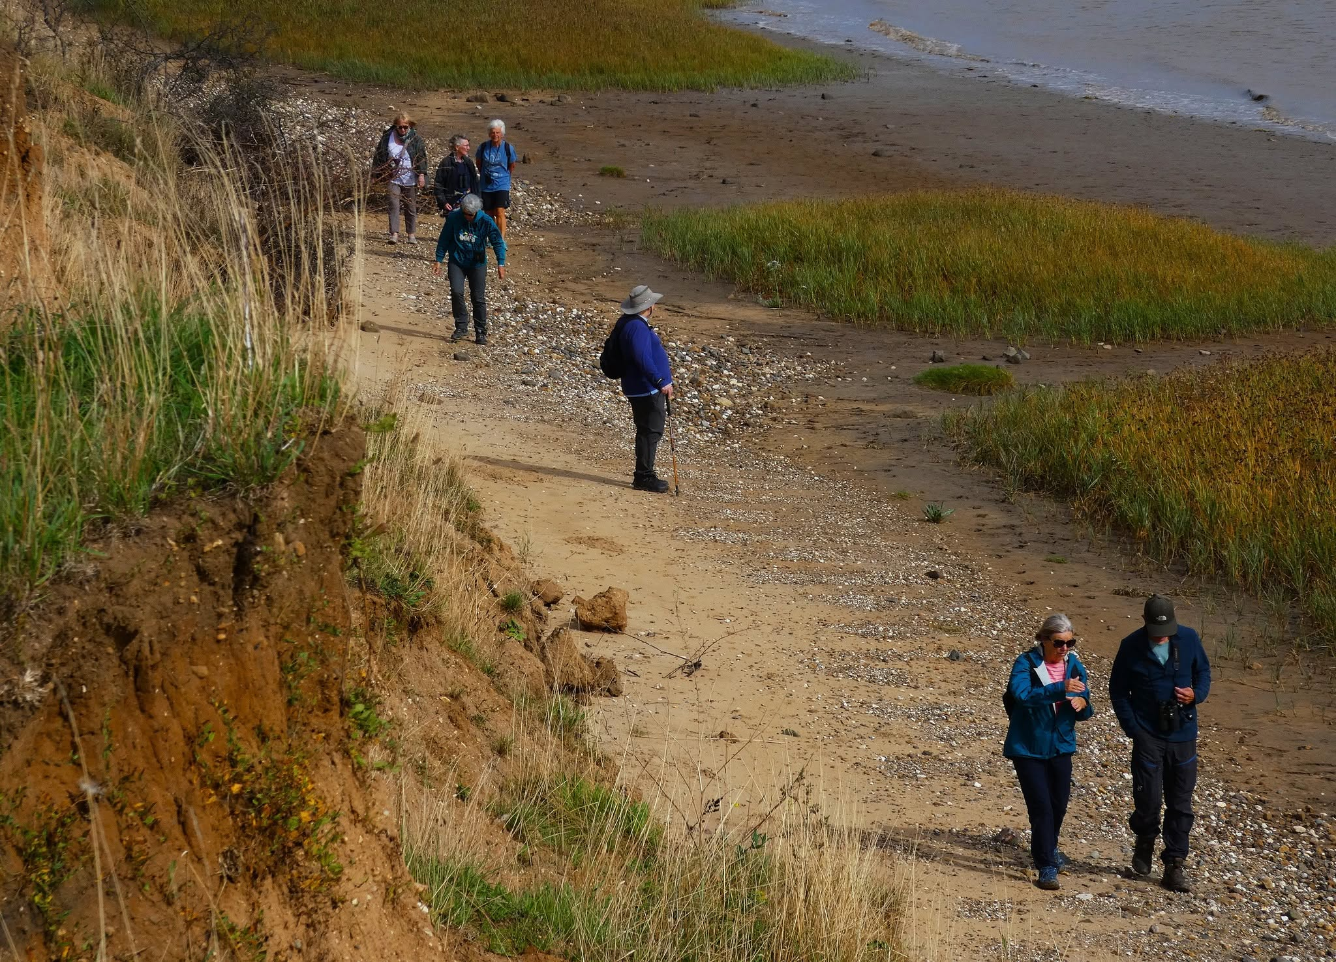
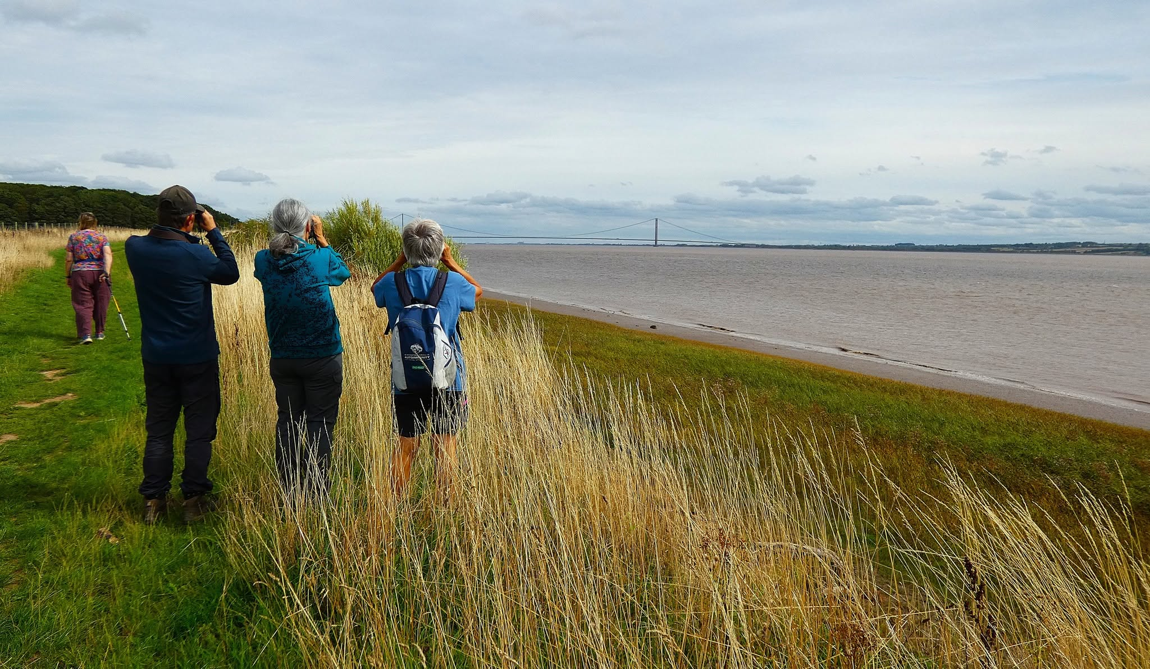

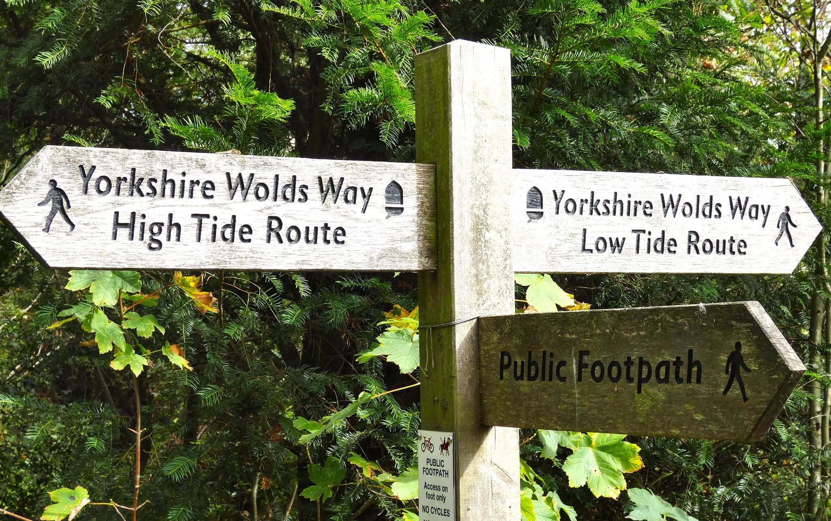
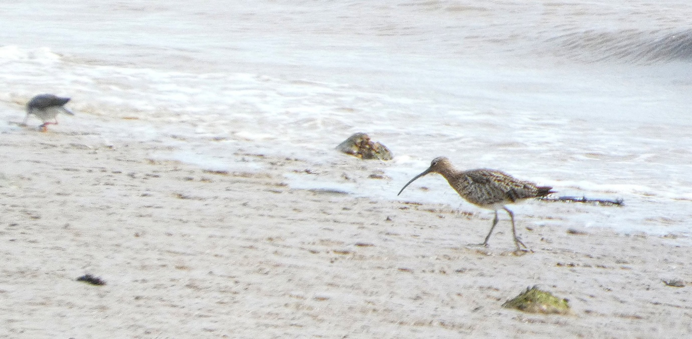
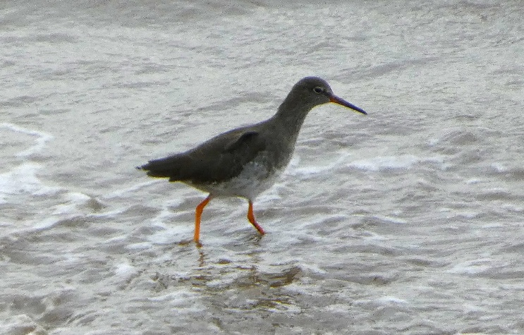
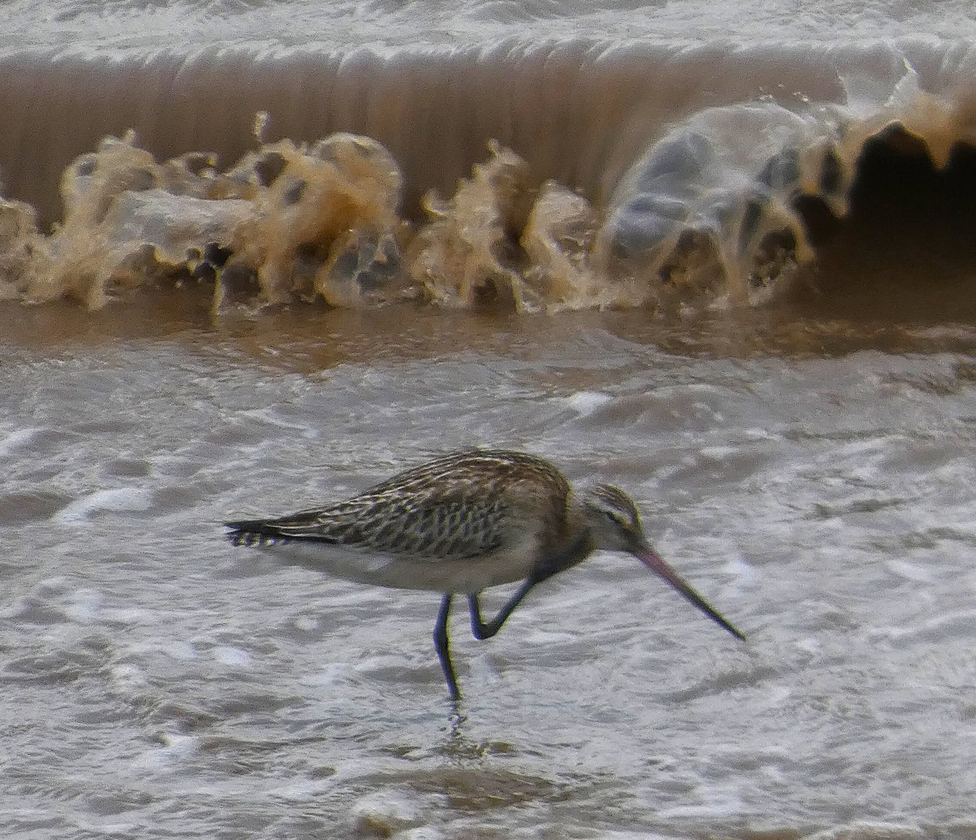
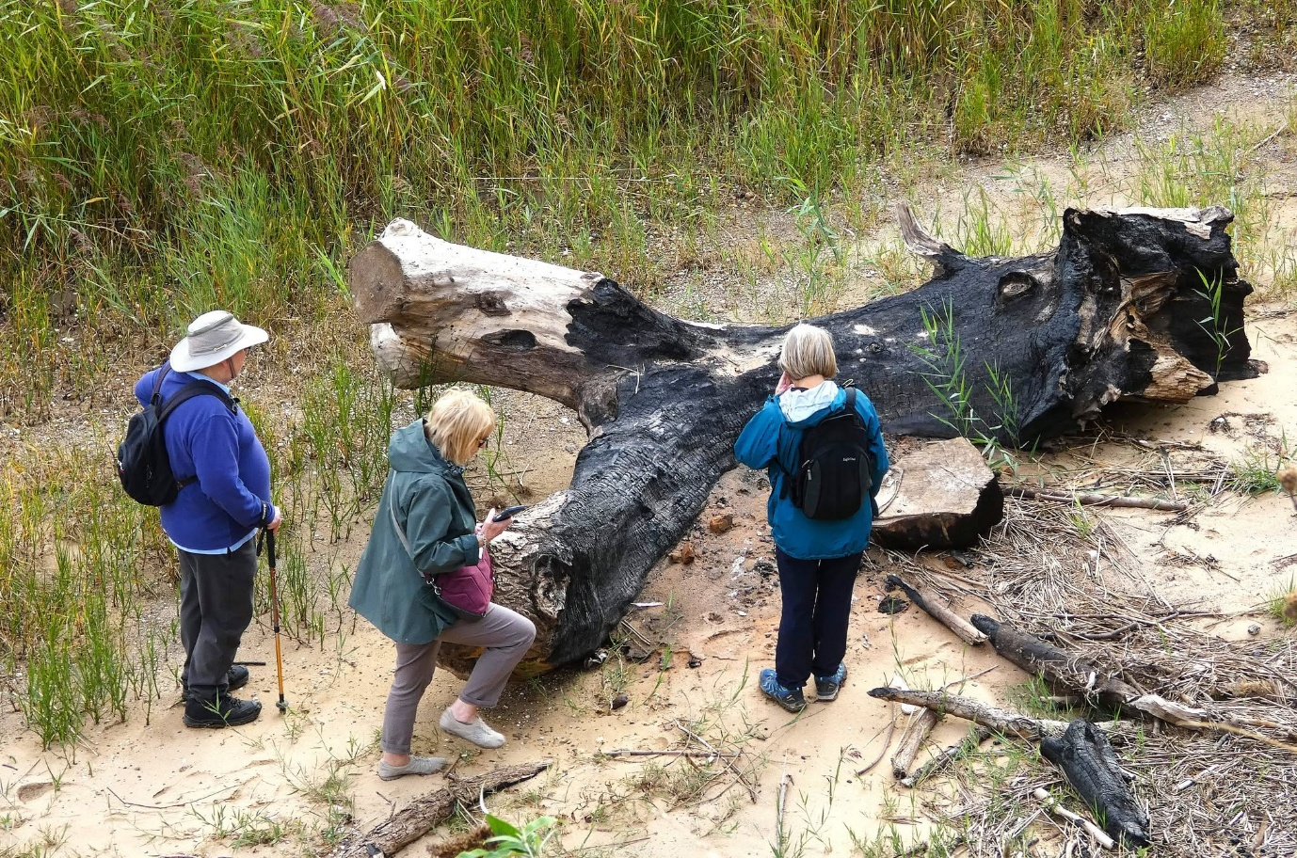
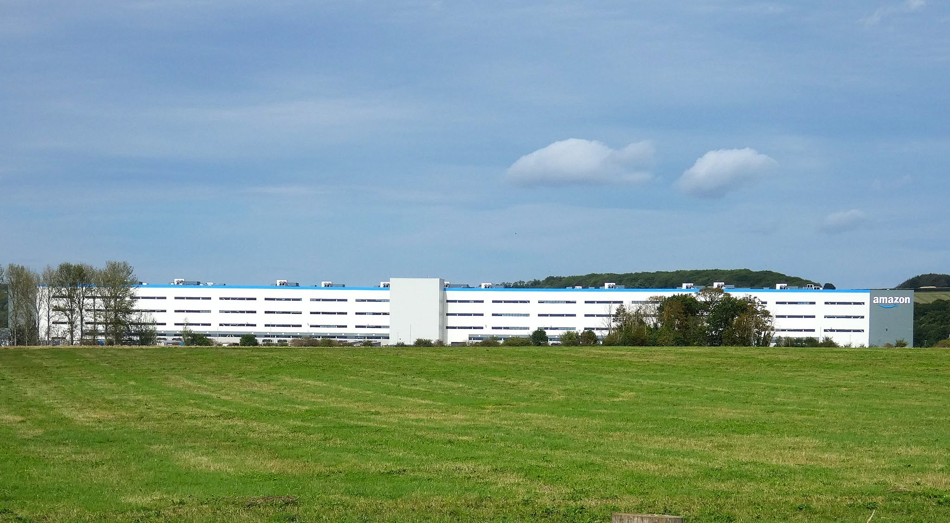

Bird list from Tricia, short but interesting, especially the Bar-Tailed Godwits.

Redshank
Curlew
Bar-Tailed Godwit
Herring Gull
Sand Martin
Carrion Crow
Mallard

Report HK

